In order to create a packaged application we need to login to App Studio

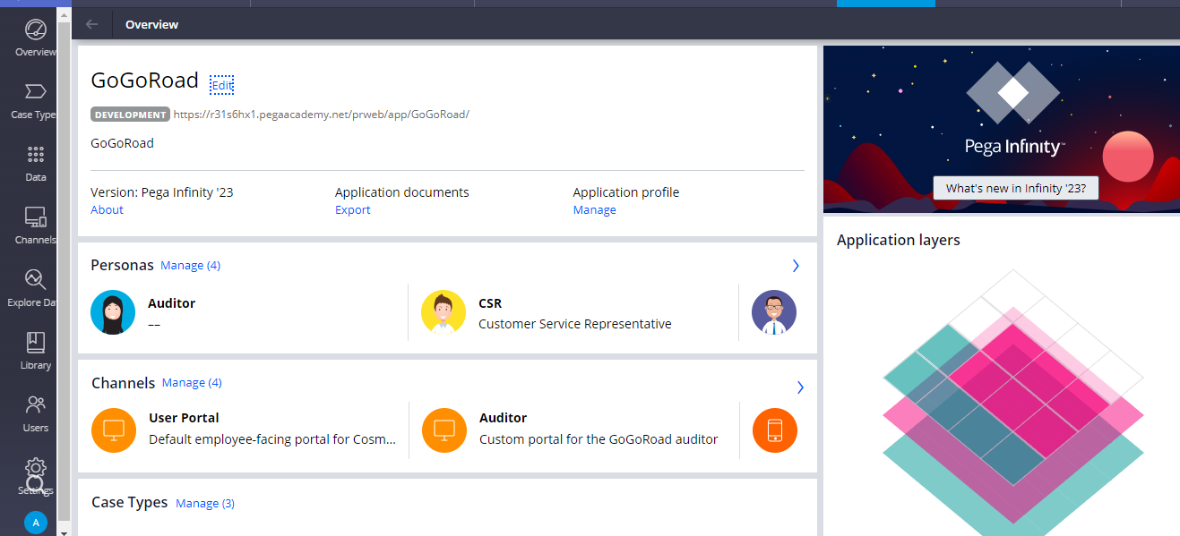

Now in the App Studio under the Application Profile click on Manage

And then a dialog box appears

Click on Download and then the RAP gets downloaded of your own application.

So now it has become much more easier to export applications through App Studio